A
SUMMER INTERNSHIP PROJECT
REPORT ON
"Interactive Food Delivery Analysis Dashboard using Microsoft Excel"
AT


WEBSKITTERS TECHNOLOGY SOLUTIONS PVT. LTD.

SUBMITTED BY
SARNENDU DAS

Under the Guidance of
Amit Chatterjee
&
Soumyajit Biswas

Dr. B. C. Roy Engineering College, Durgapur
Department of Computer Science & Engineering (AIML)

ACKNOWLEDGEMENT
I would like to express my heartfelt gratitude to all those who contributed to the successful completion of this project titled "Interactive Food Delivery Analysis Dashboard using Microsoft Excel." This project has provided me with valuable practical exposure to data analysis, dashboard development, and business intelligence using Microsoft Excel.
I sincerely thank my faculty mentor for providing continuous guidance, motivation, and constructive suggestions throughout every stage of the project. Their valuable advice, technical knowledge, and encouragement greatly helped me understand the concepts of data analysis and dashboard development.
I am also grateful to the Department of Computer Science and Engineering (AIML) and my college for providing the necessary infrastructure, learning resources, and a supportive academic environment that enabled me to complete this project successfully.
I would like to acknowledge the creators of the Food Delivery dataset, which served as the foundation of this project. Working with a real-world dataset helped me understand the practical application of Microsoft Excel in solving business problems through data visualization and reporting.
During the development of this dashboard, I gained hands-on experience in cleaning raw data, organizing large datasets, creating Pivot Tables, designing Pivot Charts, applying Conditional Formatting, using Excel formulas, and building interactive slicers. This project significantly enhanced my analytical thinking, problem-solving skills, and understanding of Business Intelligence concepts.
Finally, I extend my sincere thanks to my friends, classmates, and family members for their continuous support, encouragement, and motivation throughout the completion of this project.

TABLE OF CONTENTS
Sl. No. | Contents | Page No.
1 | Cover Page | 1
2 | Acknowledgement | 2
3 | Table of Contents | 3
4 | Project Title | 4
5 | Project Overview | 4
6 | Project Objectives | 5
7 | Dataset Description | 6
8 | Dataset Structure | 7
9 | Slicer Description | 8
10 | Technologies Used | 9-12
11 | Features Implemented | 13-17
12 | Step-wise Development Process | 18-20
13 | Changes Made During Development | 20-21
14 | Problems Faced and Solutions | 21
15 | Dashboard Analysis | 22-23
16 | Business Insights | 23
17 | Future Scope | 23
18 | Final Dashboard | 24-25
19 | Conclusion | 25

PROJECT TITLE
Interactive Food Delivery Analysis Dashboard using Microsoft Excel
PROJECT OVERVIEW
The Interactive Food Delivery Analysis Dashboard is a Business Intelligence (BI) solution developed using Microsoft Excel to analyze food delivery transaction data and present meaningful business insights through interactive visualizations. The primary objective of this project is to transform raw transactional data into an organized dashboard that enables users to understand business performance quickly and effectively.
With the rapid growth of online food delivery services, restaurants and delivery platforms generate thousands of customer transactions every day. These transactions contain valuable information regarding customer purchasing behaviour, restaurant performance, revenue generation, delivery efficiency, customer satisfaction, and payment preferences. However, analyzing large datasets manually is both time-consuming and inefficient. Therefore, an interactive dashboard was designed to automate the reporting process and simplify business analysis.
The dashboard has been created using Microsoft Excel by combining various Business Intelligence features such as Pivot Tables, Pivot Charts, Slicers, Conditional Formatting, Excel Tables, and Formulas. These features convert raw numerical data into visually appealing charts and performance indicators that help users make informed decisions.
The dashboard provides a centralized platform where management can monitor overall revenue, compare restaurant performance, evaluate city-wise sales, analyze customer ratings, identify the most popular cuisine types, compare payment methods, and observe delivery performance. Interactive slicers allow users to filter the dashboard dynamically, enabling customized analysis without modifying the original dataset.
Unlike traditional static reports, this dashboard updates automatically whenever filters are applied. This significantly reduces manual reporting efforts while improving accuracy and efficiency. Managers can easily identify high-performing restaurants, monitor operational efficiency, understand customer preferences, and make strategic business decisions based on real-time visual insights.
The project demonstrates how Microsoft Excel can be effectively used as a Business Intelligence tool for analysing operational data and presenting it in a professional, user-friendly format for easier visualization and understanding.
PROJECT OBJECTIVES
The primary objective of this project is to design and develop an interactive Microsoft Excel dashboard capable of analyzing food delivery transaction data and presenting meaningful business insights through dynamic visualizations.
The specific objectives of this project are as follows:
- To transform raw food delivery transaction records into meaningful reports using Microsoft Excel.
- To create a professional and interactive dashboard capable of supporting business decision-making.
- To monitor the total revenue generated from food delivery orders.
- To compare the sales performance of different cities.
- To identify the highest-performing restaurants based on total revenue generated.
- To analyze customer preferences by comparing various cuisine categories.
- To evaluate delivery performance using delivery time analysis.
- To analyze customer satisfaction through customer ratings.
- To compare customer payment preferences across different payment modes.
- To study monthly revenue trends for understanding business growth patterns.
- To automate the reporting process using Pivot Tables and Pivot Charts.
- To improve reporting efficiency by minimizing manual calculations.
- To provide management with accurate, timely, and visually appealing business reports.
- To develop practical skills in Microsoft Excel, Business Intelligence, and Data Visualization.
Successful completion of these objectives demonstrates how spreadsheet-based analytical tools can effectively support operational management in the food delivery industry.

DATASET DESCRIPTION

The Food Delivery dataset used in this project contains transaction-level information representing customer orders placed through an online food delivery platform. Each row in the dataset corresponds to a unique order and contains details regarding the restaurant, cuisine, payment method, order value, customer rating, and delivery performance.
The dataset serves as the primary source of information for developing the interactive dashboard. Before analysis, the dataset was carefully examined to understand its structure, identify potential data quality issues, and prepare it for visualization.
Several preprocessing activities were performed to improve data quality. The dataset was checked for duplicate records, missing values, inconsistent formatting, and incorrect data types. Date values were verified to ensure proper chronological analysis, while numerical columns such as Order Amount, Delivery Time, and Customer Rating were validated to ensure calculation accuracy.
The cleaned dataset was then converted into an Excel Table to facilitate Pivot Table creation and improve data management. Using structured data significantly enhanced dashboard performance and simplified the creation of dynamic reports.
The dataset provides sufficient information to analyse multiple business dimensions, including revenue generation, restaurant performance, customer satisfaction, payment behaviour, cuisine popularity, and operational efficiency.
This dataset forms the backbone of the entire dashboard and supports every chart, KPI, and analytical report presented throughout this project.

DATASET STRUCTURE
Column Name | Data Type | Description
Order ID | Integer | Unique identification number assigned to each customer order.
Order Date | Date | Date on which the food order was placed.
City | Text | City where the order was delivered.
Restaurant Name | Text | Name of the restaurant fulfilling the order.
Cuisine Type | Text | Category of food ordered by the customer.
Order Amount | Currency | Total order value paid by the customer.
Delivery Time (Minutes) | Integer | Time taken to deliver the order after confirmation.
Payment Mode | Text | Mode of payment such as Cash, Card, UPI, or Wallet.
Customer Rating | Decimal | Customer feedback rating provided after delivery.

SLICER DESCRIPTION
One of the most important interactive components of the dashboard is the use of Slicers. Slicers provide a user-friendly graphical interface that allows users to filter Pivot Tables and Pivot Charts with a single click. Instead of manually applying filters to each Pivot Table, slicers dynamically update all connected reports simultaneously, making dashboard navigation simple and efficient.
The dashboard includes slicers for important business dimensions such as City, Restaurant Name, Cuisine Type, Payment Mode, and Order Month (if applicable). These slicers are connected to all Pivot Tables using the Report Connections feature available in Microsoft Excel.
For example, selecting a specific city automatically updates every chart and KPI to display information only for that city. Similarly, selecting a particular cuisine displays revenue trends, restaurant performance, payment preferences, and customer ratings related to that cuisine. This interactive functionality allows users to perform customized analyses without changing the original dataset.
Slicers greatly improve the usability of the dashboard by enabling quick comparisons between different categories. Business managers can instantly analyse sales performance across multiple cities, evaluate individual restaurant performance, study customer payment behaviour, and identify the most popular cuisine categories.
The inclusion of slicers transforms the dashboard from a static reporting tool into a fully interactive Business Intelligence solution capable of supporting real-time business analysis and strategic decision-making.
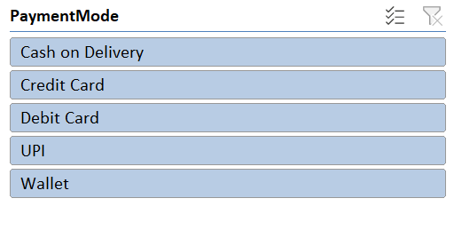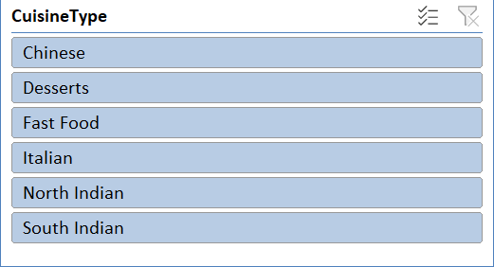
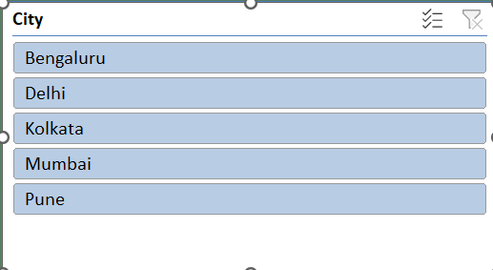

TECHNOLOGIES USED
The Interactive Food Delivery Analysis Dashboard was developed entirely using Microsoft Excel, utilizing its powerful data analysis and visualization capabilities. Microsoft Excel is one of the most widely used spreadsheet applications for data management, business reporting, and dashboard creation. By combining multiple Excel features, raw transaction data was transformed into meaningful business insights that support effective decision-making.
The following technologies and Excel tools were used during the development of this project:
Technology / Tool | Purpose
Microsoft Excel | Dashboard development, data analysis, and report creation
Excel Tables | Organizing and managing structured data
Pivot Tables | Summarizing large datasets
Pivot Charts | Visual representation of summarized data
Slicers | Interactive filtering of dashboard reports
Conditional Formatting | Highlighting important values and trends
Excel Formulas | Data calculations and transformations
Sorting & Filtering | Organizing transaction records
Date Grouping | Monthly trend analysis
Dashboard Formatting | Creating a professional and interactive interface

MICROSOFT EXCEL
Microsoft Excel was used as the primary software for data analysis and dashboard development. It provided an efficient environment for importing, organizing, cleaning, and analysing the Food Delivery dataset.
Excel's flexibility allowed the project to integrate calculations, Pivot Tables, charts, and slicers into a single interactive dashboard. The software also enabled automatic updating of reports whenever filters were applied, making the dashboard dynamic and user-friendly.

EXCEL TABLES
The raw Food Delivery dataset was converted into an Excel Table before analysis. Converting data into a structured table provides several advantages such as automatic expansion when new records are added, easier formula management, and improved compatibility with Pivot Tables.
Using Excel Tables also ensured that all Pivot Tables and charts remained connected to the original dataset, reducing the possibility of data inconsistencies.

PIVOT TABLES
Pivot Tables played a significant role in summarizing the raw transaction data into meaningful reports. Rather than manually calculating totals and averages, Pivot Tables automatically grouped and summarized information based on different categories.
Multiple Pivot Tables were developed to analyse:
- Total Revenue by City
- Revenue by Restaurant
- Revenue by Cuisine Type
- Monthly Revenue Trend
- Customer Rating Analysis
- Delivery Time Analysis
- Payment Mode Distribution
These Pivot Tables formed the foundation for all dashboard visualizations.

PIVOT CHARTS
Pivot Charts were created directly from the Pivot Tables to convert summarized numerical information into graphical representations.
Different chart types were selected depending on the nature of the data.
Examples include:
- Column Charts
- Bar Charts
- Line Charts
- Pie Charts
- Doughnut Charts
These visualizations make it easier for users to understand trends, compare values, and identify business patterns quickly.

SLICERS
Interactive slicers were added to improve dashboard usability.
Instead of manually filtering Pivot Tables, users can simply click on a slicer to update every chart simultaneously.
The dashboard includes slicers such as:
- City
- Restaurant Name
- Cuisine Type
- Payment Mode
- Order Month (if available)
Slicers provide a clean and intuitive interface for customized business analysis.

CONDITIONAL FORMATTING
Conditional Formatting was used wherever necessary to improve readability and highlight important values.
Different formatting rules were applied to emphasize:
- High Revenue
- Low Revenue
- Best Performing Restaurants
- Highest Customer Ratings
- Exceptional Delivery Times
This allows users to identify key information immediately without manually comparing values.

EXCEL FORMULAS
Several built-in Excel formulas were utilized during the development process to support calculations and data preparation.
Examples include:
- SUM()
- AVERAGE()
- COUNT()
- IF()
- ROUND()
- TEXT()
- MONTH()
- YEAR()
These formulas simplified calculations and improved the accuracy of dashboard metrics.
SORTING AND FILTERING
Sorting and Filtering tools were used extensively while preparing the dataset.
The data was sorted according to:
- Order Date
- Order Amount
- Restaurant Name
- Customer Rating
Filtering helped verify the accuracy of records and identify any inconsistencies before visualization.
DASHBOARD DESIGN
A professional dashboard layout was designed on a separate worksheet.
The dashboard follows modern Business Intelligence design principles, including:
- Clean layout
- Consistent spacing
- Professional colour palette
- Interactive elements
- Proper chart alignment
- Easy navigation
- Clear titles
- Uniform fonts
The objective was to create a dashboard that is both visually attractive and easy to understand.
FEATURES IMPLEMENTED
The Interactive Food Delivery Dashboard consists of multiple analytical reports designed to provide comprehensive insights into business performance.
Each visualization has been carefully selected to answer specific business questions and assist management in making informed decisions.

A. CITY-WISE REVENUE ANALYSIS
Description
This visualization compares the total revenue generated from food delivery orders across different cities. The chart helps identify the contribution of each city toward the overall business revenue.
City-wise analysis enables management to evaluate geographical performance and understand regional demand for food delivery services.
Purpose
- Compare revenue across cities.
- Identify high-performing locations.
- Detect low-performing markets.
- Support regional business expansion.
- Assist marketing campaign planning.
Business Benefit
Management can allocate resources more effectively by identifying cities with strong customer demand while also developing strategies to improve performance in cities with lower revenue.
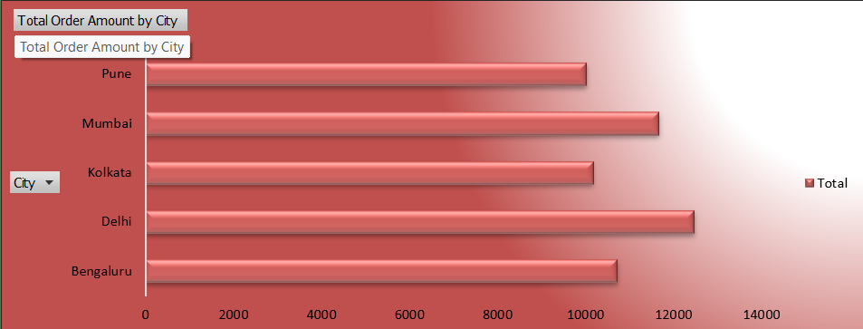
B. RESTAURANT PERFORMANCE ANALYSIS
Description
This chart compares the revenue generated by different restaurants available in the dataset.
Restaurant performance analysis helps identify which restaurant partners contribute the highest sales and which restaurants require performance improvement.
Purpose
- Compare restaurant revenue.
- Identify top-performing restaurants.
- Measure business contribution.
- Evaluate restaurant popularity.
Business Benefit
The analysis supports partnership decisions, promotional campaigns, and operational planning by highlighting the restaurants generating maximum business.
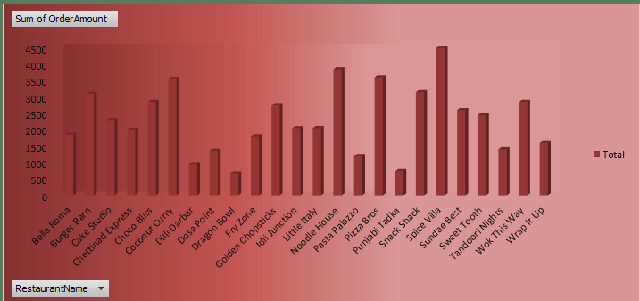
C. CUISINE TYPE ANALYSIS
Description
Cuisine Type Analysis compares customer preferences across different food categories such as Indian, Chinese, Italian, Fast Food, Continental, or any cuisine types present in the dataset.
Understanding cuisine popularity enables restaurants to improve menu planning and optimize inventory.
Purpose
- Identify popular cuisines.
- Compare food preferences.
- Understand customer demand.
- Improve menu offerings.
Business Benefit
The results help restaurants introduce promotional offers, optimize menu items, and improve customer satisfaction by focusing on high-demand cuisines.
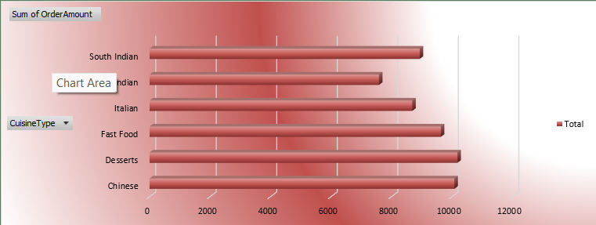
D. MONTHLY REVENUE TREND
Description
This line chart displays the monthly trend of food delivery revenue over time.
Monthly trend analysis helps identify seasonal demand, business growth, and periods of high or low customer activity.
Purpose
- Analyse revenue growth.
- Compare monthly sales.
- Identify seasonal patterns.
- Forecast future demand.
Business Benefit
The analysis assists management in planning inventory, staffing, and promotional campaigns according to expected demand.
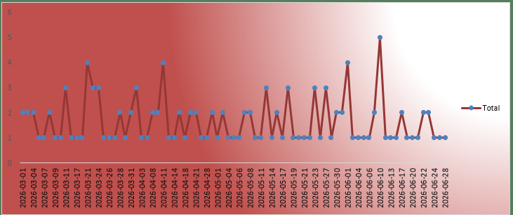
E. PAYMENT MODE ANALYSIS
Description
This chart compares different payment methods used by customers for placing food delivery orders.
The dashboard evaluates customer payment behaviour by comparing Cash, Card, UPI, Wallet, or other available payment methods.
Purpose
- Study customer payment behaviour.
- Compare digital and cash transactions.
- Promote preferred payment options.
- Improve payment convenience.
Business Benefit
The analysis helps businesses strengthen digital payment infrastructure and design promotional offers for frequently used payment methods.
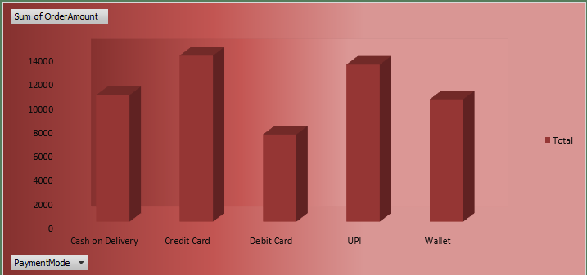
F. DELIVERY TIME ANALYSIS
Description
Delivery Time Analysis evaluates operational efficiency by measuring the time taken to complete food deliveries.
Fast and reliable delivery plays a significant role in improving customer satisfaction and business reputation.
Purpose
- Monitor delivery performance.
- Identify delays.
- Compare delivery efficiency.
- Improve logistics.
Business Benefit
The dashboard helps management identify operational bottlenecks and optimize delivery routes to reduce waiting time.
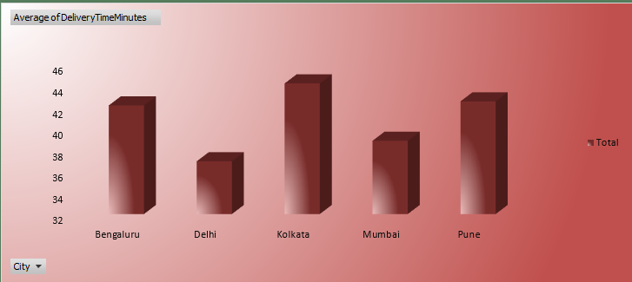
G. CUSTOMER RATING ANALYSIS
Description
Customer Ratings represent customer satisfaction with food quality, delivery experience, and overall service.
This visualization compares rating distributions to evaluate business performance from the customer's perspective.
Purpose
- Monitor customer satisfaction.
- Identify service quality.
- Improve customer retention.
- Detect performance issues.
Business Benefit
Businesses can use customer feedback to improve delivery quality, restaurant service, and overall customer experience.
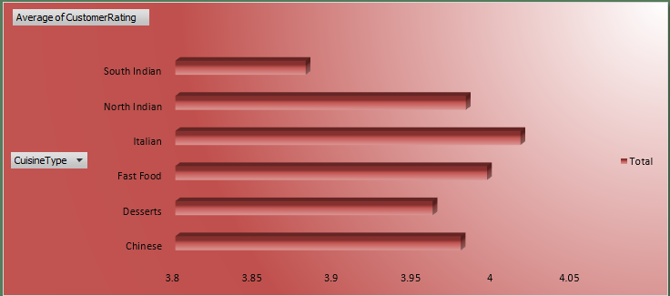

STEP-WISE DEVELOPMENT PROCESS
The Interactive Food Delivery Analysis Dashboard was developed using a systematic approach to ensure data accuracy, effective visualization, and an interactive user experience. The project involved several stages, beginning with data collection and ending with dashboard testing and validation. Each step contributed to transforming raw food delivery data into meaningful business insights.

Step 1: Dataset Collection
The Food Delivery dataset was collected and imported into Microsoft Excel. The dataset contains transaction details such as Order ID, Order Date, City, Restaurant Name, Cuisine Type, Order Amount, Delivery Time, Payment Mode, and Customer Rating. This data served as the foundation for the dashboard.
Activities Performed
- Imported the dataset into Excel.
- Verified column names and records.
- Stored the raw data in a separate worksheet.
Step 2: Data Inspection
The dataset was inspected to understand its structure and identify any missing values, duplicate records, or formatting issues before analysis.
Activities Performed
- Checked data types.
- Verified missing values.
- Identified duplicate records.
- Reviewed numerical and date fields.
Step 3: Data Cleaning and Preparation
The dataset was cleaned to ensure accuracy and consistency. Date fields were formatted correctly, numerical values were verified, and the dataset was converted into an Excel Table for easier analysis.
Activities Performed
- Formatted Order Date.
- Removed duplicate records (if any).
- Checked blank cells.
- Converted data into an Excel Table.
Step 4: Pivot Table Creation
Pivot Tables were created to summarize the dataset and generate reports for different business metrics.
The Pivot Tables included:
- Revenue by City
- Restaurant Performance
- Cuisine Analysis
- Monthly Revenue
- Payment Mode Analysis
- Customer Rating Analysis
Step 5: Pivot Chart Development
Pivot Charts were generated from the Pivot Tables to present the summarized information visually. Different chart types such as column, bar, line, pie, and doughnut charts were used depending on the analysis.
Activities Performed
- Created Pivot Charts.
- Added chart titles and data labels.
- Applied consistent formatting.
Step 6: Dashboard Design
A separate worksheet was created to design the final dashboard. Charts, KPI cards, and slicers were arranged using a clean layout with a consistent colour theme to improve readability.
Activities Performed
- Designed dashboard layout.
- Added KPI cards.
- Positioned charts and slicers.
- Applied professional formatting.
Step 7: Slicer Integration
Interactive slicers were added to allow users to filter the dashboard dynamically. The slicers were connected to all Pivot Tables using Report Connections.
The dashboard includes slicers for:
- City
- Restaurant Name
- Cuisine Type
- Payment Mode
- Order Month (if applicable)
Step 8: Testing and Validation
The final dashboard was tested to ensure that all Pivot Tables, charts, KPI cards, and slicers displayed accurate information. The results were compared with the original dataset to verify correctness before final submission.
Activities Performed
- Refreshed Pivot Tables.
- Verified chart accuracy.
- Tested slicers.
- Reviewed dashboard formatting.

CHANGES MADE DURING DEVELOPMENT
During the development of the Interactive Food Delivery Analysis Dashboard, several improvements were made to enhance its functionality, appearance, and user experience. The initial dashboard consisted of basic Pivot Tables and simple charts. After reviewing the dashboard, additional interactive features and formatting enhancements were introduced to make it more professional and informative.
The major improvements made during development include:
- Added interactive slicers for dynamic filtering.
- Improved dashboard layout and chart alignment.
- Applied a consistent colour theme.
- Added KPI cards for quick performance overview.
- Enhanced chart formatting with titles and data labels.
- Standardized fonts, spacing, and dashboard design.
These improvements made the dashboard easier to use and provided a better visual representation of business data.

[INITIAL DASHBOARD SCREENSHOT]
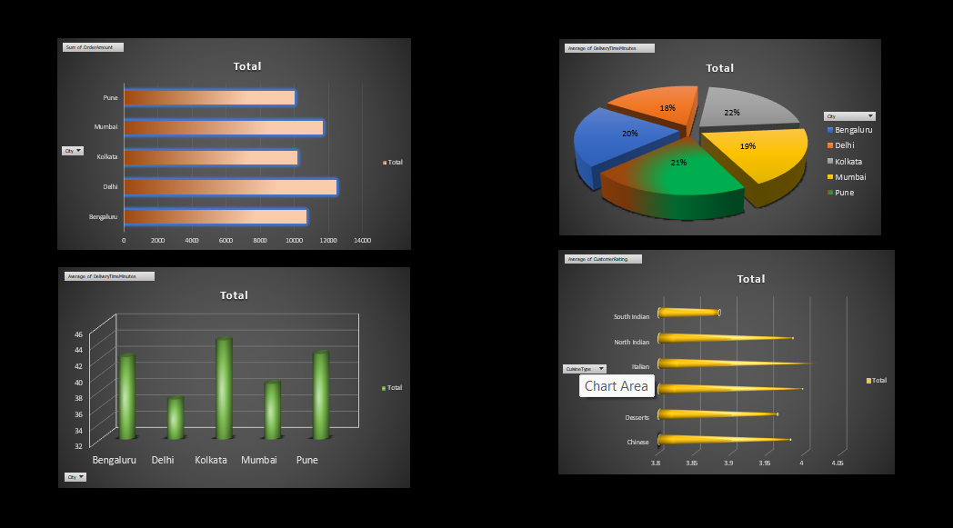
[FINAL DASHBOARD SCREENSHOT]
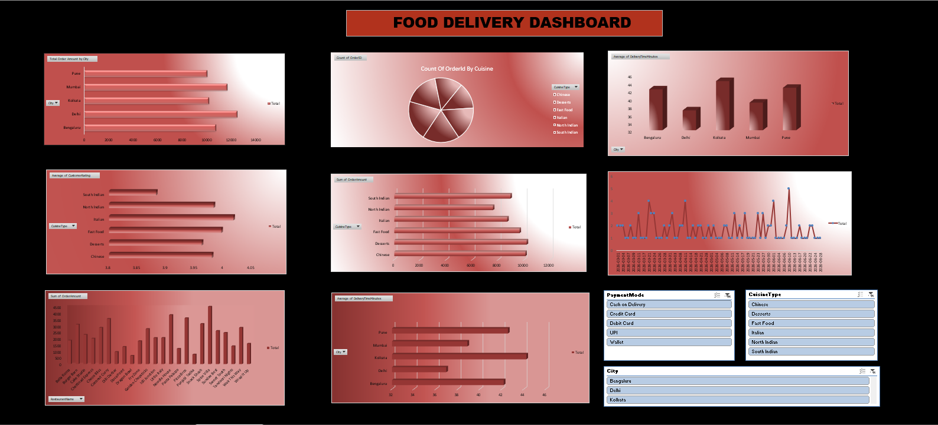

PROBLEMS FACED AND SOLUTIONS
During the project, several challenges were encountered while creating the dashboard. Each issue was resolved using appropriate Excel features to ensure the dashboard functioned accurately.

Problem | Solution
Incorrect Date Format | Converted the Order Date column into the proper Date format.
Pivot Tables not updating | Used the Refresh All option after modifying the dataset.
Charts not responding to slicers | Connected all Pivot Tables using Report Connections.
Dashboard alignment issues | Used Excel alignment and formatting tools.
Choosing suitable chart types | Selected chart types according to the nature of the data.
Maintaining a consistent design | Applied a professional colour theme and uniform formatting.

DASHBOARD ANALYSIS
The Interactive Food Delivery Dashboard provides a clear overview of business performance by converting raw transaction data into meaningful visual reports. The dashboard allows users to analyse revenue, restaurant performance, cuisine preferences, delivery efficiency, customer ratings, and payment methods through interactive charts and slicers.
Revenue Analysis
The Revenue Analysis chart compares sales across different cities and helps identify locations contributing the highest revenue. This information supports regional business planning and resource allocation.
(IMAGE ALREADY PROVIDED)

Restaurant Performance
This visualization compares the revenue generated by different restaurants. It helps identify top-performing restaurants and evaluate their contribution to overall business performance.
(IMAGE ALREADY PROVIDED)
Cuisine Analysis
Cuisine Analysis highlights customer preferences for different food categories. This information helps businesses understand demand patterns and improve menu planning.
(IMAGE ALREADY PROVIDED)
Delivery Time Analysis
Delivery Time Analysis evaluates operational efficiency by comparing the time taken to complete food deliveries. It helps identify delays and improve delivery performance.
(IMAGE ALREADY PROVIDED)
Payment Mode Analysis
This chart compares customer payment methods such as Cash, Card, UPI, and Wallet. It helps businesses understand payment preferences and promote convenient digital payment options.
(IMAGE ALREADY PROVIDED)
Customer Rating Analysis
Customer Ratings provide valuable feedback on service quality and customer satisfaction. Analysing ratings helps identify strengths and areas requiring improvement.
(IMAGE ALREADY PROVIDED)
BUSINESS INSIGHTS
The dashboard provides several important business insights that support better decision-making. Based on the analysis, management can:
- Identify the highest revenue-generating city.
- Recognize the best-performing restaurant.
- Determine the most popular cuisine type.
- Analyse customer payment preferences.
- Monitor average delivery performance.
- Evaluate customer satisfaction using ratings.
- Identify trends that support business growth and operational improvements.
These insights help businesses improve customer service, optimize operations, and make informed strategic decisions.

FUTURE SCOPE
The Interactive Food Delivery Analysis Dashboard can be further enhanced by integrating advanced analytical tools and modern Business Intelligence technologies. Although the current dashboard effectively analyses historical transaction data, several additional features can improve its functionality and business value.
Some possible future enhancements include:
- Integration with Power BI for advanced dashboards and real-time reporting.
- Connecting the dashboard with a live database to automatically update new orders.
- Implementing sales forecasting using Machine Learning techniques.
- Developing customer segmentation based on ordering behaviour.
- Analysing delivery partner performance and route optimization.
- Creating mobile-friendly dashboards for managers.
- Adding automated email reports and scheduled dashboard updates.
- Expanding the dashboard with additional KPIs such as repeat customers, cancellation rates, and order frequency.
These improvements will make the dashboard more scalable, intelligent, and suitable for real-world business applications.

PROJECT LEARNING OUTCOMES
This project provided practical exposure to Microsoft Excel and Business Intelligence concepts. Throughout the development process, several technical and analytical skills were acquired.
The key learning outcomes include:
- Understanding the importance of data cleaning and preparation.
- Creating structured datasets using Excel Tables.
- Developing Pivot Tables for data summarization.
- Designing Pivot Charts for effective data visualization.
- Building interactive dashboards using Slicers.
- Applying Excel formulas for calculations and analysis.
- Improving dashboard formatting and presentation skills.
- Understanding how business data can support decision-making.
- Enhancing analytical thinking and problem-solving abilities.
The project also strengthened practical knowledge of data visualization techniques and demonstrated how Excel can be used to create professional business dashboards.

FINAL DASHBOARD
The final Interactive Food Delivery Analysis Dashboard combines all analytical reports into a single interactive interface. It enables users to monitor revenue, compare restaurant performance, analyse cuisine preferences, evaluate delivery efficiency, study customer ratings, and examine payment methods through dynamic charts and filters.
The dashboard is designed to be user-friendly, visually appealing, and interactive. Users can instantly filter reports using slicers, allowing quick analysis of different business scenarios without modifying the original dataset.
The completed dashboard serves as an effective reporting tool for restaurant owners, food delivery companies, and business managers by providing valuable insights that support operational planning and strategic decision-making.

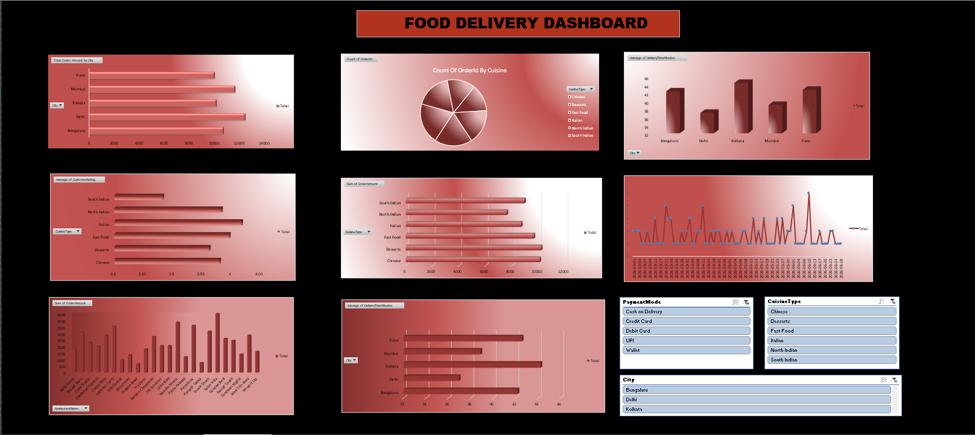

CONCLUSION
The Interactive Food Delivery Analysis Dashboard using Microsoft Excel successfully transforms raw transaction data into meaningful business insights through interactive visualizations and analytical reports. By utilizing Microsoft Excel features such as Pivot Tables, Pivot Charts, Slicers, Excel Tables, Conditional Formatting, and Formulas, the project demonstrates an efficient approach to organizing, analysing, and presenting business data.
The dashboard enables users to evaluate important business metrics, including revenue trends, restaurant performance, cuisine popularity, payment preferences, delivery efficiency, and customer satisfaction. The use of interactive filters allows users to perform customized analysis quickly, reducing manual effort and improving reporting efficiency.
This project has enhanced practical knowledge of data cleaning, data visualization, dashboard design, and business analytics while strengthening skills in Microsoft Excel. It also highlights the importance of Business Intelligence tools in supporting data-driven decision-making and improving operational performance.
Overall, the Interactive Food Delivery Analysis Dashboard provides a simple, efficient, and scalable solution for analysing food delivery operations. It demonstrates how Microsoft Excel can be used as an effective Business Intelligence platform to convert raw data into valuable insights that assist organizations in making informed business decisions.

